Temporal demand

When doing our analysis of the temporal demand, we start by cleaning the data further, as we only want to work with start and end time of the rides. From here we add some depth to data, in which we make variables for which day of the week the ride took place, the month, and the duration of the ride. After this is done, we can start our actual analysis of the data.

Firstly, we produce a graph where we show how many rides we had within each hour of the day. For rides spanning the hour mark, we count them from the hour the ride began.

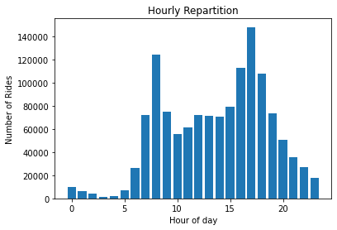

We clearly see two spikes from our data. One at 8 o’clock, and one again at 17 o’clock. This is very likely closely tied to a work day from where you are expected to be at the office at 9, and then leave after 17. This tells us that one of the largest drivers for demand are people working office jobs. Notably also is that the second spike is higher than the first, which could indicate that some people use another mode of transport to get to their job, but then take a bike home when they get off work.

Looking at different holidays throughout the year, we find different patterns than those from the entire year.

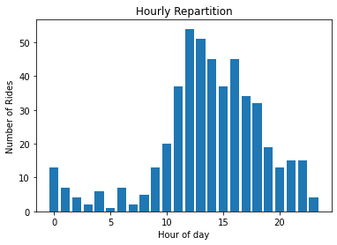

For new years day, we see that demand slopes down as we approach midnight, and customers are at their chosen place of celebration. Notably also, is that we see more activity through the night, then when we look at the entire dataset.

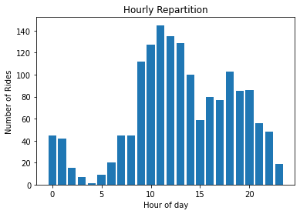

For memorial day, we still see the two spikes from the whole dataset, but with the first spike being the largest. We also find that the definitions are not as sharp, meaning that the demand has a smaller variation. We also see more activity from midnight to 2 o’clock than before.

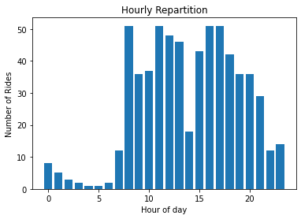

Looking at labour day, we see two spikes again, although much smoother this time. We also notice a smoother drop from the second peak, which could indicate that the customers not working, but attending celebrations still use the bikes to get home.

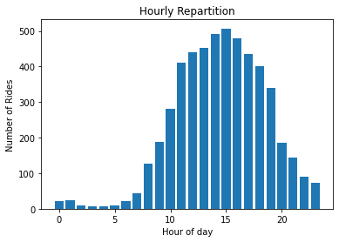

For thanksgiving, we only have one spike, centred around 15 o’clock, which could tell us that consumers use the bikes to get to their chosen place of celebration. Noticeable is also the numbers of rides. At the height, there is around 500 rides, compared to a max of 50 for labour day, and 140 for memorial day. During the night, we have a very low number of rides, which could tell us that customers most likely either leave before midnight, or spend the night.

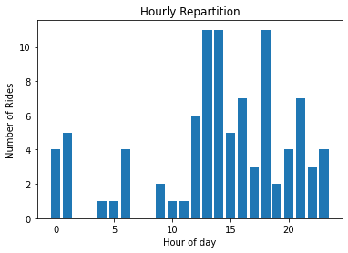

The last holiday we look at is Christmas day. Here, the most noticeable thing is the very low number of rides. This tells us that very few customers travel during the day but got to their place of celebration before the 25th, and leave at a later day.

Lastly, we look at the Super Bowl, to see what the usage looks like on that day. In 2017, the Super Bowl was played in Houston, between the Atlanta falcons and the New England Patriots, the latter of which is located 28 miles outside Boston.



Since the Super Bowl is played on a Sunday in February, we see do not see the normal spikes we would see on a working day. Instead, we see people using the bikes to get home from a night out, before daily use resumes. Like Christmas, we see a very low number of rides, so it is difficult to come to see a distinct pattern in the usage.

Finally, we look days and month, to see if we detect any pattern there.

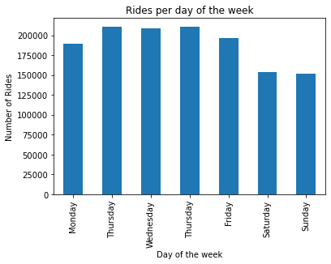

For days, we see that the most usage takes place during the week, with a drop in the weekends. This could further tell us that the primary user of these bikes are customers who use it to commute to and from work.

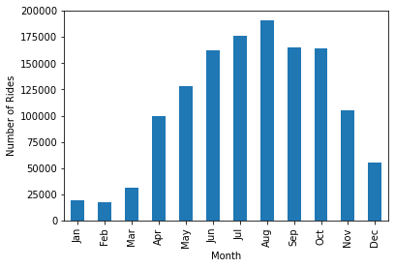

Looking at the months, we see a noticeable difference between the seasons. Interestingly, this bar chart lines up very well with the average monthly temperature in Boston, which tells us that, above all, demand is dictated by temperature.

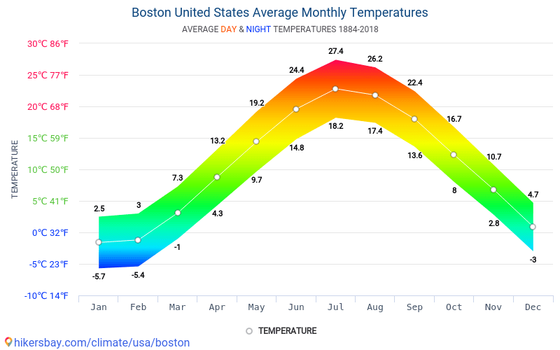

Limitation: lack of cultural knowledge. What is memorial day and labour day exactly.